Bayesian-thinking workshop/group assignment: Density dependence in forests
Minutes from meeting on 07-06-2021
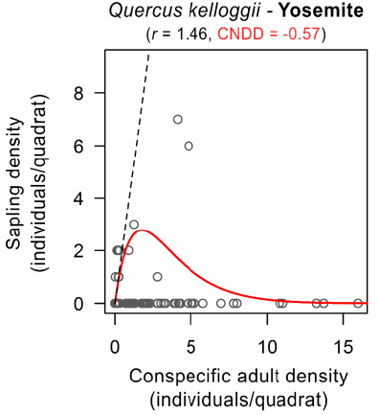
Focus of the project: We agreed that it would be interesting to focus on the problem of measurement error in the density of tree adults in the types of observational data typically used in studies of density dependence in forest tree communities. Previous approaches have been based on regression approaches that did not consider this measurement error (Fig. 1). Specifically, we thought it would be interesting to explore whether we can construct adult density as a latent variable, not only using the plot-scale observations, but also regional information on species composition and (continental-scale) variation in habitat and climatic conditions. We also agreed that to assess whether specfic approach(es) work well or not, it would be good to start with simulated data for which true adult densities and strengths of density dependence are known.

Figure 1: Density dependence estimation approaches used by LaManna et al. (2017, left) and Johnson et al. (2012, right). While the two estimation methods differed slightly, neither considered measurement error in the independent variable, i.e. adult density.

Thoughts on the statistical modelling framework: Florian explained how the following framework could be provide the basis for the analyses (Fig. 2):
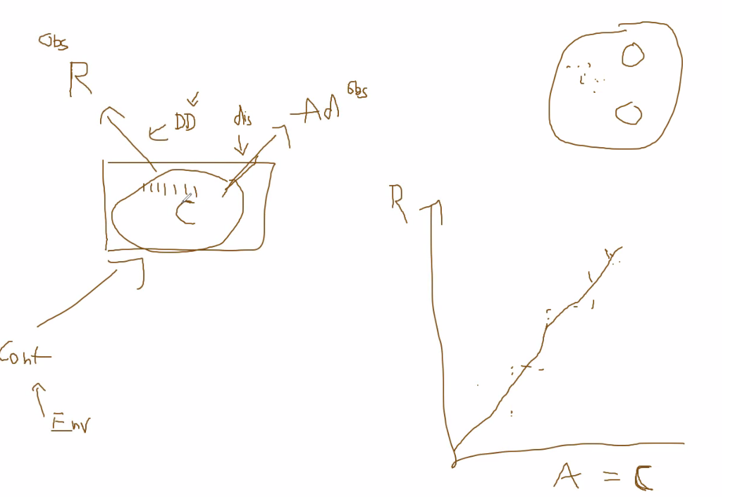
Community/ecosystem composition
Observed Adult density in the plot
Observed recruit density in the (sub)plot
Continental-scale species presence/abundance
Use of proportion of the species in C, rather than observed A
The strength of density-dependence
Abiotic/environmental variables

Figure 2: Conceptual framework discussed
- Continental-scale species presence abundance/Community ecosystem composition: It might be worthwhile to have a close look at this paper by Clark et al. (2017): https://esajournals.onlinelibrary.wiley.com/doi/full/10.1890/13-1015.1 . A first look suggests that the paper has used a similar approach as discussed during the meeting, i.e. simulating the community using MCMC and the FIA plot observation data. A closer look, the specific details may clarify whether their results are more in line with the Continental-scale presence/abundance component of the above framework, or the Community/ecosystem composition.

- Spatial scale of dispersal versus spatial scale of density-dependent interactions: We discussed that the spatial scale of dispersal (the community-ecosystem scale, dozens of meters for sure, but long-distance dispersal/fait-tailed dispersal kernels imply distances even much farther than that) may be larger than the spatial scale at which density-dependent interactions occur (suggested to be mostly between 0-15 m or so). The difference might be relevant in case there is significant clustering at the smaller scale, i.e. that the sampling algorithm needs to take this into account when simulating species abundances at smaller scales (e.g. a very rare species that occurs very clustered, may need to have a very strong bimodal density pattern in the simulated replicates). It might be possible to get a sense of this clustering / beta diversity within the community/ecosystem using some spatially explicit large plot data (like shown below, left: all trees, right: spatial distribution of one species), like the ForestGEO plots, but from North America if to be linked to the FIA data.
Community scale
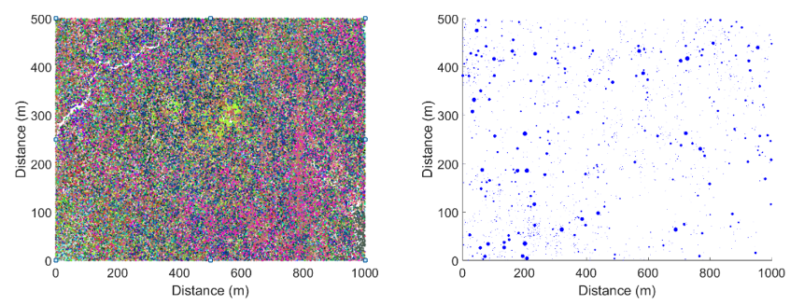

Interaction scale

- Thoughts for the simulation of data:
- We could make the simplifying assumption that the current spatial distribution of recruits is the result of density-independent interactions with the current generation of adults, and that this adult distribution is static on the timescale at which recruit dynamics occur. This would allow for just placing a bunch of adults in a grid, not changing their positions and or numbers during the simulation.
- We might want to consider a community of a small number of tree species that differ in the strength of conspecific density dependence that they experience (so we can see if we can pick these differences up). It might be good to consider a weak heterospecific effect as well, so that recruits experience a difference between a true gaps in space (with the very low pressure of adults on seedlings) versus areas where conspecific adults are not present.
- We could assume a simple dispersal kernel (e.g. just a Gaussian), and a number of seeds that are distributed by each tree each timestep based on this kernel. Would kernel width need to vary between species? May depend on the research question?
- After seeds have been depositied, they may be subject to background mortality, which is the modified (increased always?) based on the local presence of adult trees. Again, this could be a kernel, so that the impacts of adults closer by are more heavily weiged. (In line with point 2) above, these latter sets of kernels could have different widths than the dispersal kernels).
- Should we then simulate the above processes for a number of timesteps at which recruit numbers have stabilized? Or is the transient response relevant?
- Something along the above lines would be not too difficult to implement it seems, but in this paper, something similar has been done: https://myersecologylab.com/wp-content/uploads/2021/01/LaManna_etal_2021_Ecosphere.pdf . So it might be an idea to have a look at their seed dispersal kernel model code: https://zenodo.org/record/4079469#.YMD0hPZuIuU

Brainstorm Research Questions/Goals:
Maybe one way to think about structuring the above points a bit further is to brainstorm a little bit about the specific questions we would like to answer (just to be clear, below are questions to the group for the brainstorm about the research questions, rather than the research questions themselves):
- As Yannek described: Comparison of the simple model/naïve approach previously employed versus the “adults-as-latent-variable approach”: could we do this for simulated data at the ecosystem scale first, so we do not yet have to incorporate the continental scale variation at first?

- Additional exploration of how inferred strengths of density-dependence depend on species traits such as dispersal distance or background mortality?

- Include continental-scale variation at a second step (still using simulated data)?

- After these two simulation steps check with the FIA data?

From before the meeting (i.e. nothing new, was already on Git):
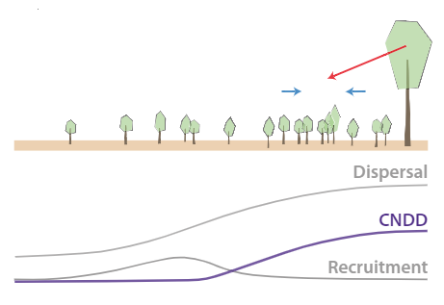
Background: The Janzen-Connell hypothesis provides an explanation for the large diversity of tree species in forests. A key component of this hypothesis is that tree species may attract/accumulate species-specific enemies during their lifetime, reducing the fitness of their offspring within the local environment, and thereby controlling/maintaining the species’ abundance. This latter mechanism is commonly referred to as Conspecific Negative Density Dependence (CNDD, e.g. Hülsmann et al. 2021, Fig 1). Mathematical models suggest that when CNDD is relatively strong compared to density-dependent effects exerted by other species (Heterospecific Density Dependence, HNDD), it indeed can promote the coexistence of many tree species within a community (e.g. Eppinga et al. 2018).
Given the size and lifespan of trees, measuring CNDD and HNDD experimentally is challenging. Hence, previous studies have aimed to infer these strengths from observational data of adult trees and seedlings from forest inventory surveys (e.g. LaManna et al. 2017a,b). Providing the appropriate analysis framework for this type of data is challenging, as both variables (i.e. adult density and seedling density) are error-prone proxies (Dickie et al. 2012; Detto et al. 2019), which may lead to a regression dilution effect that interacts with the abundance of tree species investigated, for example (Hülsmann and Hartig 2018; Hülsmann et al. 2021). The idea of this project is to develop a Bayesian analysis framework to study in more detail how error-prone proxies may propagate into the uncertainty of model estimates, and/or to provide a framework that integrates these observations with information known from pot experiments with tree seedlings. Hence, the project would aim to identify to what extent forest inventory-type (and experimental) data is (are) able to constrain important parameters describing density dependence of tree species. Below, an empirical dataset to do so is described, but this dataset may be further complemented with simulated data.

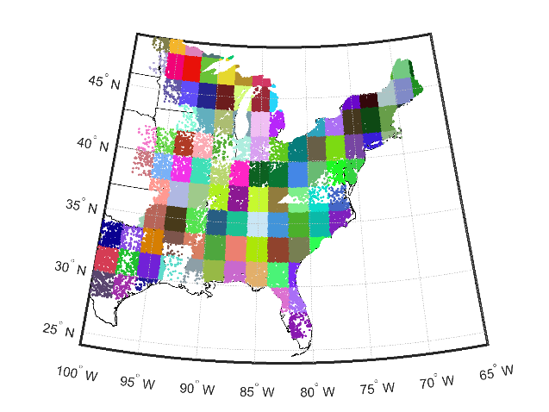
Available dataset we could work with: We can use the dataset extracted by Johnson et al. (2012) and further analyzed in Eppinga et al. (2018), of the US Forest Service’s Forest Inventory and Analysis (FIA) census from 2009. All plots east of the 100th meridian were selected (~200,000 plots, with ~7m radius). At ~ 60,000 locations, 2-4 plots (referred to as subplots) were measured. In total, the plots contain ~ 1,000,000 observations, where an observation could be: i) the number of adults of a tree species in the plot and their cumulative basal area; ii) the number of tree seedlings of a particular tree species, as observed in a ~ 2m radius microplot. The previous studies quantified strengths of conspecific and heterospecific density dependence of all tree species for each grid cell in which they were observed ≥ 30 times.
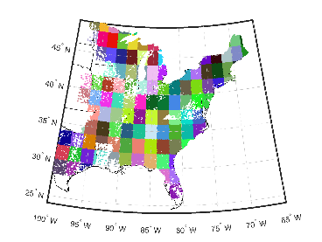
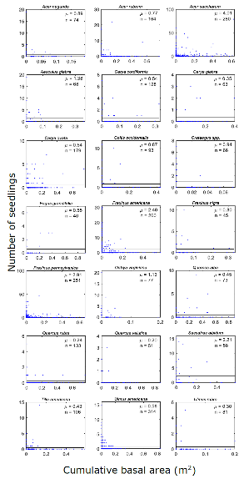
Previous approach: The previous studies used a standard regression approach (exponential fit with negative binomial error distribution), using adult species density (either # adults in plot or cumulative basal area in plot) as independent variable and seedling density (# individuals in the subplot) as the dependent variable. Conspecific effects were determined using seedling data and adult data from the same species; only an average heterospecific effect was calculated, i.e. summing the adult data of all competitor tree species to create one aggregate independent variable. The slope parameter was then used as a measure of density dependence, with negative slopes indicating negative density dependence, and positive slopes indicating positive density dependence.
Ideas on how to proceed, with the group assignment: As noted above, a Bayesian framework may provide a more explicit consideration of the limitations inherent to the observational type of dataset used, but also may allow for utilizing knowledge obtained independently from pot experiments. The project could be developed into multiple directions, according to the group’s interests. Examples of potential directions could be (but are certainly not limited to):
- Use a hierarchical modelling approach (e.g. Schliep et al. 2017), where subplots are used as location replicates to estimate observation error in adult densities.
- Use a hierarchical modelling approach, where climatic variables are directly included as co-variates (rather than separate fitting for 2 by 2 degree grid cells).
- Use recent experimental studies of density dependence of tree species to inform priors for the density dependence parameters. Priors could be species-specific is information is available (Bennett et al. 2017), or based more generally on mycorrhizal association (Steidinger et al. 2019)
- Compare the empirical dataset with simulated datasets with known strengths of density dependence to infer the explanatory power of the data.

References:

Bennett, J.A., Maherali, H., Reinhart, K.O., Lekberg, Y., Hart, M.M., Klironomis, J. Plant-soil feedbacks and mycorrhizal type influence temperature forest population dynamics. Science 355: 181-184. LINK.

Chisholm, R.A., Fung, T. 2018. Comment on: Plant diversity increases with the strength of negative density dependence at the global scale. Science 360: eaar4685. LINK.

Detto, M., Visser, M.D., Wright, S.J., Pacala, S.W. 2019. Bias in the detection of negative density dependence. Ecology Letters 22: 1923-1939. LINK.

Dickie, I.A., Hurst, J.M., Bellingham, P.J. 2012. Comment on: Conspecific negative density dependence and forest diversity. Science 338: 469. LINK.

Eppinga, M.B., Baudena, M., Johnson, D.J., Jiang, J., Mack, K.M.L., Strand, A.E., Bever, J.D. 2018. Frequency-dependent feedback constrains plant community coexistence. Nature Ecology and Evolution 2: 1403-1407. LINK.

Johnson, D.J., Beaulieu, W., Bever, J.D., Clay, K. 2012. Conspecific negative density dependence and forest diversity. Science 336: 904-907. LINK.

Hülsmann, L., Chisholm, R.A., Hartig, F. 2021. Is variation in conspecific negative density dependence driving tree diversity patterns at large scales? Trends in Ecology and Evolution 36: 151-163. LINK.

Hülsmann, L., Hartig, F. 2018. Comment on: Plant diversity increases with the strength of negative density dependence at the global scale. Science 360: eaar2435. LINK.

LaManna, J.A., Belote, R.T., Burkle, L.A., Catano, C.P., Myers, J.A. 2017. Negative density dependence mediates biodiversity-productivity relationships across scales. Nature Ecology and Evolution 1: 1107-1115. LINK.

LaManna, J., Mangan, S.A., Alonso, A. et al. 2017. Plant diversity increases with the strength of negative density dependence at the global scale. Science 356: 1389-1392. LINK.

Schliep, E.M., Gelfand, A.E., Clark, J.S., Tomasek, B.J. 2017. Biomass prediction using a density-dependent diameter distribution model. The Annals of Applied Statistics 11: 340-361. LINK.

Steidinger et al. 2019. Climatic controls of decomposition drive the global biogeography of forest-tree symbioses. Nature 569: 404-408. LINK.

